Software Engineering Assignment: SDLC Model Selection
1.Introduction
An Online Shopping Website is a web-based application that allows users to browse products, add items to a cart, make payments, and track orders. It involves multiple components such as user interface, product catalog, payment gateway integration, order management, and customer support.
This type of system is dynamic, user-driven, and frequently updated based on customer needs and market trends.
2.Selected SDLC Model
Agile Model
3.Justification
The Agile SDLC model is the most suitable for an Online Shopping Website due to the following reasons:
1. Requirement Flexibility
Customer requirements in e-commerce frequently change (offers, UI updates, features like wishlist, AI recommendations). Agile supports continuous changes even in later stages.
2. High User Involvement
Agile encourages regular feedback from users and stakeholders, which is crucial for improving user experience (UX) in shopping platforms.
3. Incremental Delivery
The website can be developed in parts (modules) such as:
- Product listing
- Cart system
- Payment gateway
This allows early deployment and faster time-to-market.
4. Risk Management
Frequent testing in each iteration helps identify bugs early, reducing risks in complex systems like payment processing.
5. Faster Updates & Improvements
Online shopping platforms need constant updates (festive offers, discounts, UI changes). Agile supports rapid releases and continuous improvement.

4.Comparison with Other Models
1.Waterfall Model
- Not flexible for changing requirements
- Late testing phase may cause major issues
- Not suitable for dynamic applications like e-commerce
2.Spiral Model
- Good for high-risk projects but complex and costly
- Requires extensive risk analysis, which may slow development
- Not ideal for fast-paced online shopping platforms
5.Diagram (Agile Model)
https://media.geeksforgeeks.org/wp-content/uploads/20230728093121/Agile-Development-Models.webp
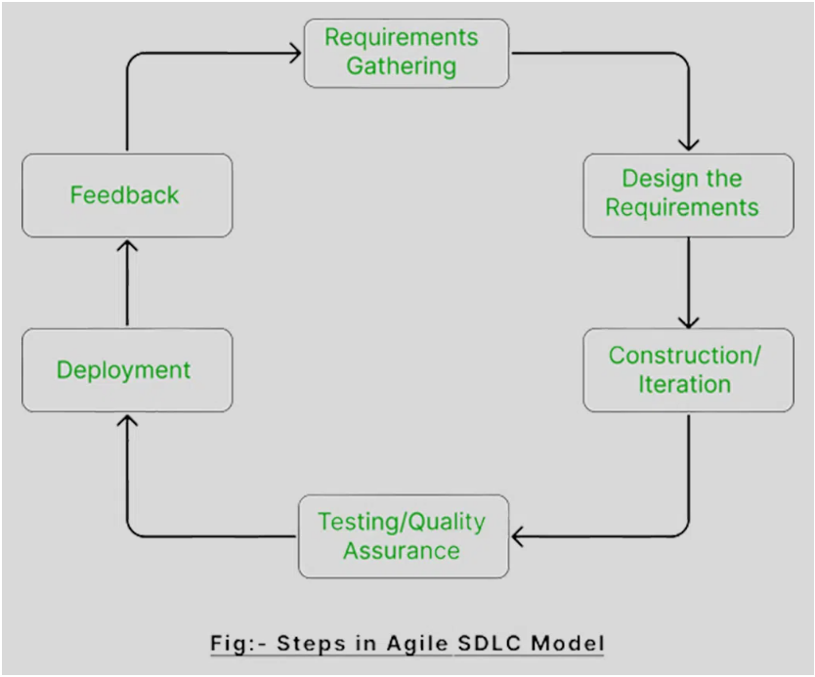

6.Conclusion
The Agile Model is the best choice for an Online Shopping Website because it provides flexibility, faster delivery, continuous feedback, and adaptability to changing user needs. These features are essential for maintaining competitiveness and user satisfaction in modern e-commerce systems.

